**ASSIGNMENT 1**

# CREATE TABLE COMMAND:

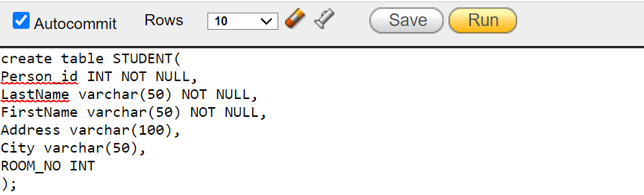

# OUTPUT:



# DESC COMMAND:



# OUTPUT:

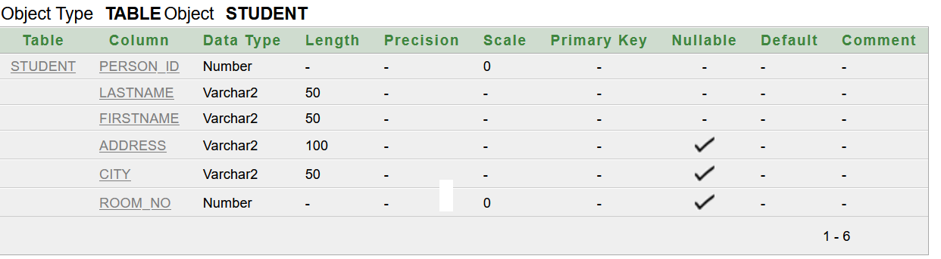

# INSERT INTO COMMAND:

## INSERT SINGLE ROW COMMAND:

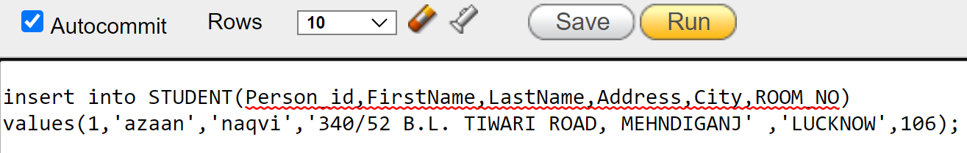

# OUTPUT:

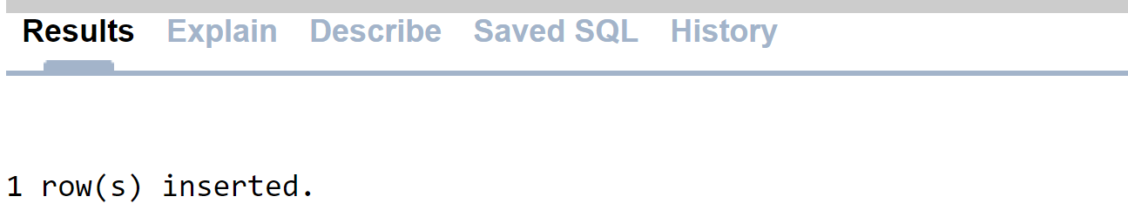

## INSERT MULTIPLE ROWS COMMAND:

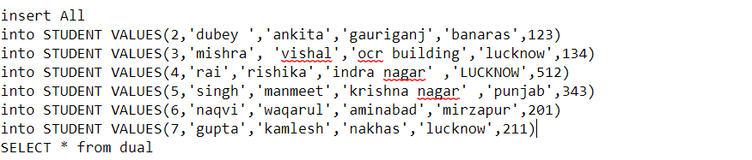

# OUTPUT:

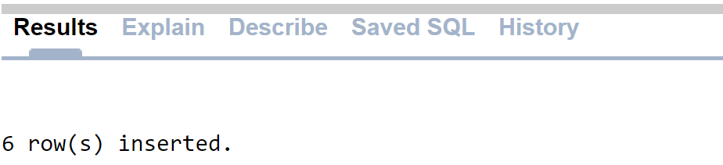

# SELECT COMMANDS:



# OUTPUT:

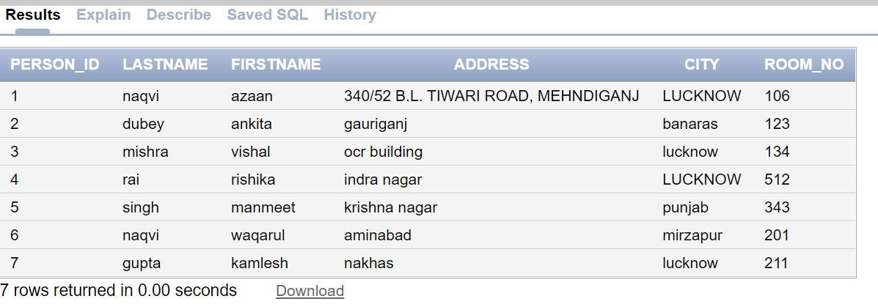

## USING WHERE CLAUSE:



# OUTPUT:

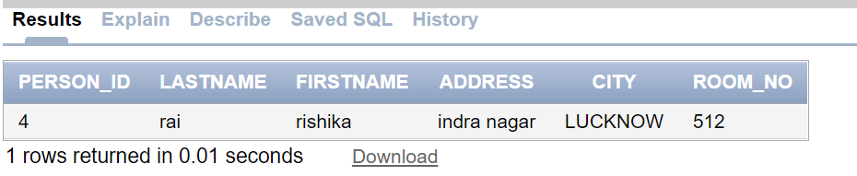

## USING COUNT :



# OUTPUT:

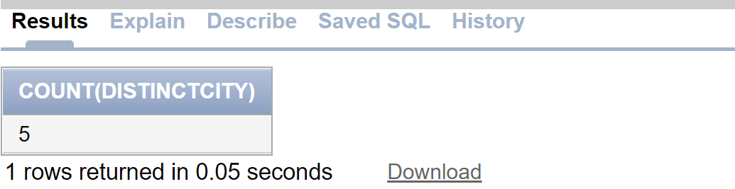

## USING DISTINCT :



# OUTPUT:

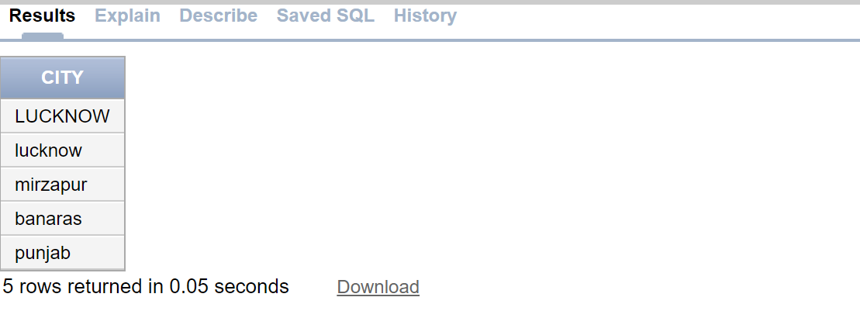

# ALTER COMMAND:



**OUTPUT:**



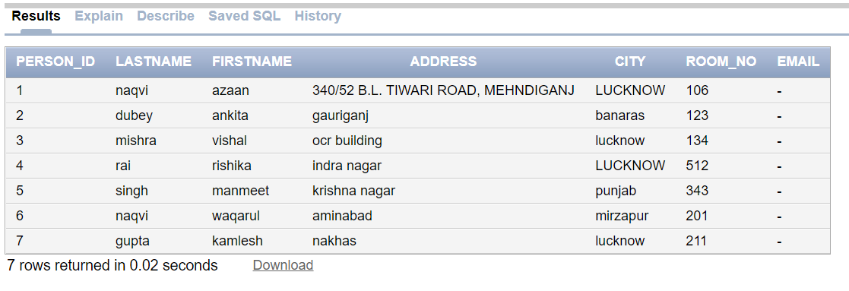

# DROP COMMAND:

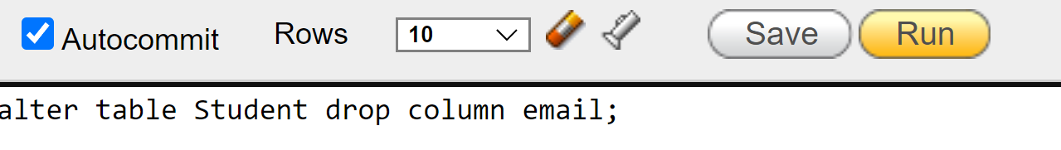

# OUTPUT:

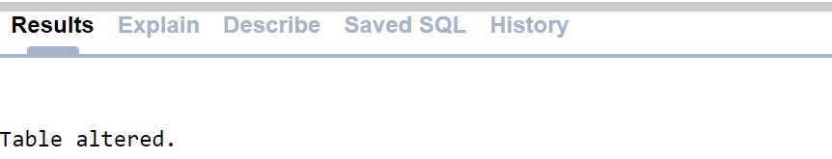



# MODIFY COMMAND:

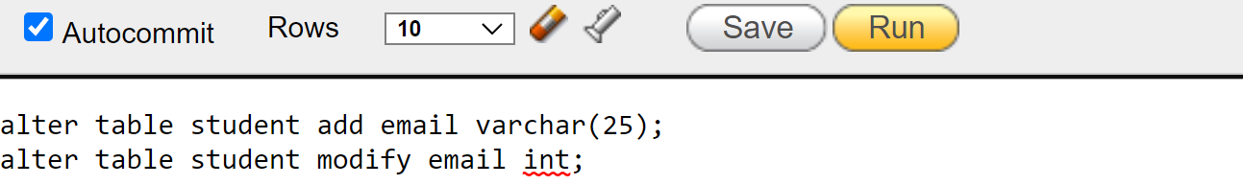

# OUTPUT:



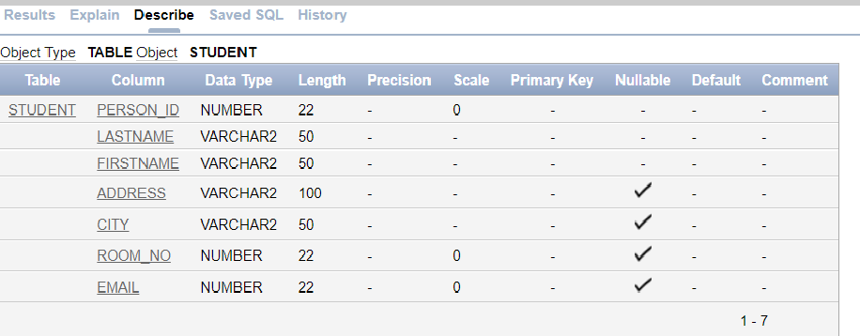

# INSERT SELECTIVE INFORMATION COMMAND:

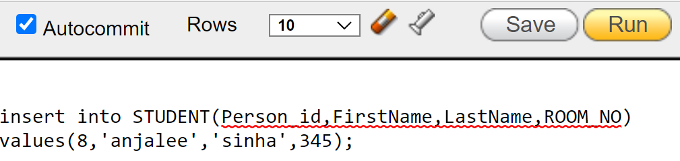

# OUTPUT:

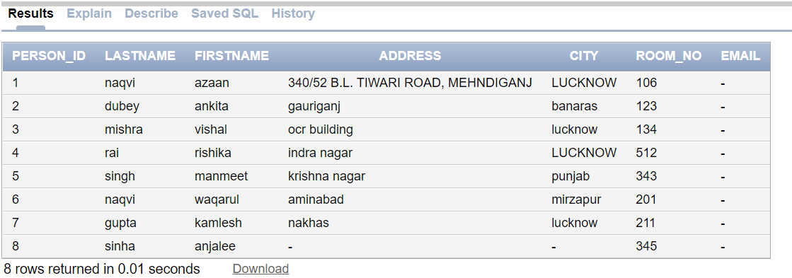

# UPDATE COMMAND:

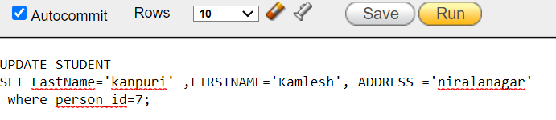

# OUTPUT:

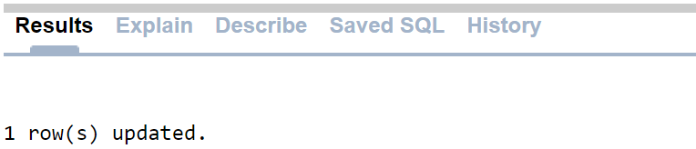

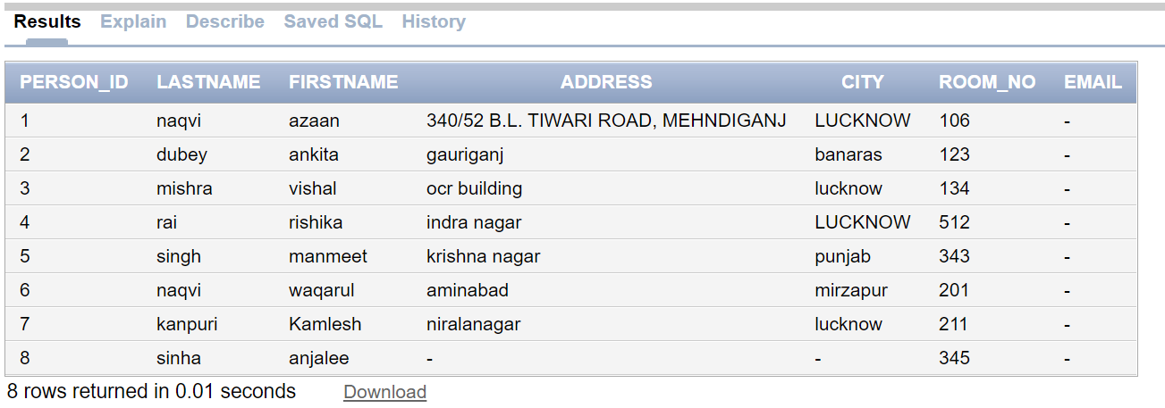

1. **UPDATE ALL COLUMNS COMMAND:**



# OUTPUT:



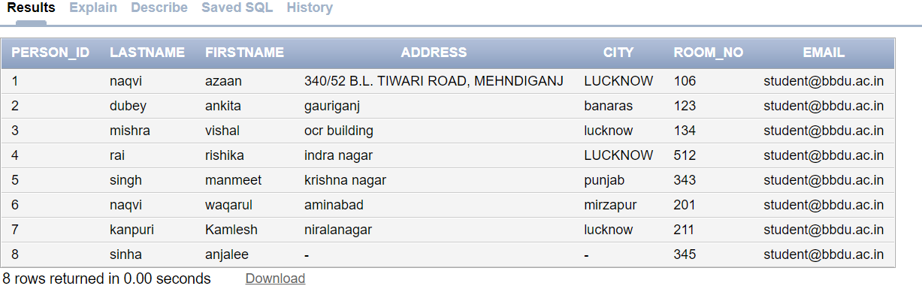

# ADD COLUMN COMMAND:

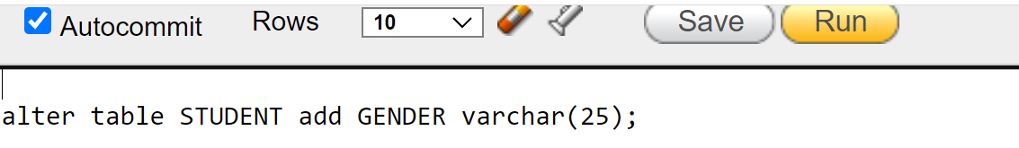

**OUTPUT:**

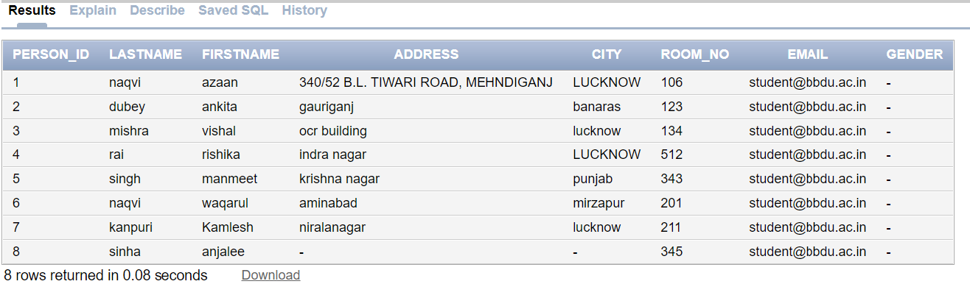

# DELETE COMMAND:

## DELETE ONE ROW COMMAND:

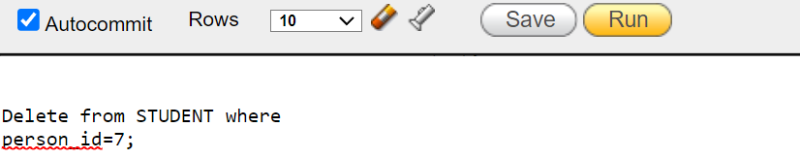

# OUTPUT:

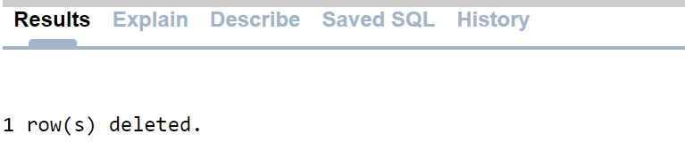

## DELETE ALL ROWS COMMAND:



# OUTPUT:

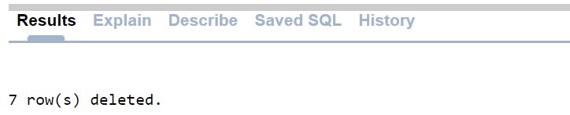

# CREATE ANOTHER TABLE :

## CREATE TABLE COMMAND:

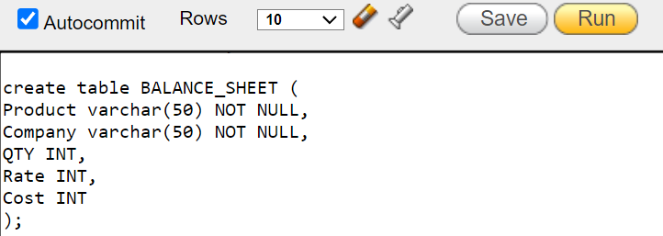

## INSERT MULTIPLE ROWS COMMANDS:

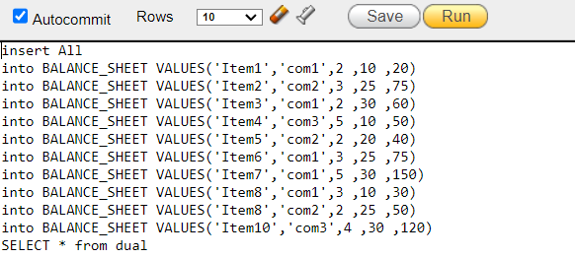

## SELECT COMMANDS:



# OUTPUT:

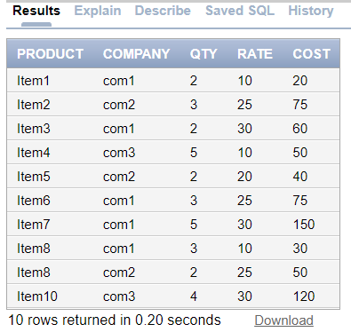

# AGGREGATE FUNCTION COMMANDS :

## COUNT ROWS COMMANDS:

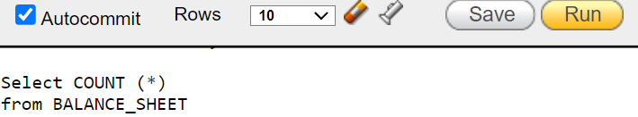

# OUTPUT:

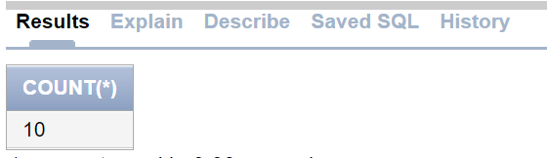

## COUNT DISTINT QTY COMMAND:

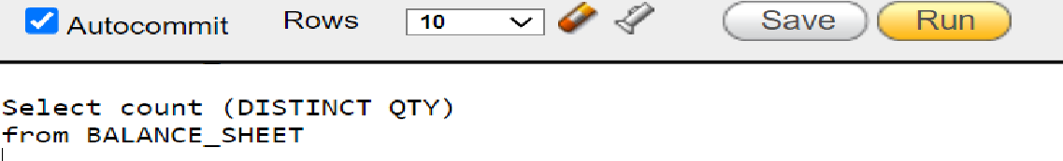

# OUTPUT:



## COUNT NOT NULL QTY COMMAND:



# OUTPUT:



## COUNT WITH WHERE CONDITION COMMAND:

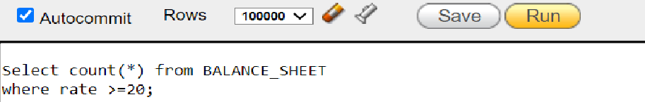

# OUTPUT:



## GROUP BY COMMAND:

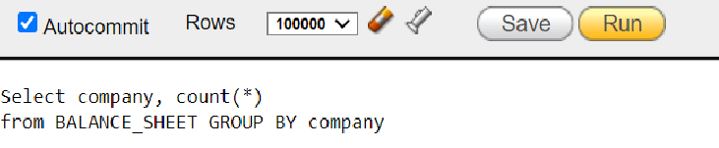

# OUTPUT:

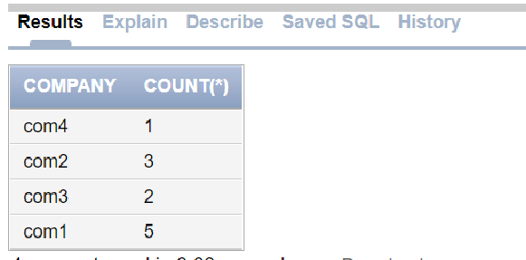

## COUNT DISTINT COMPANY COMMAND:

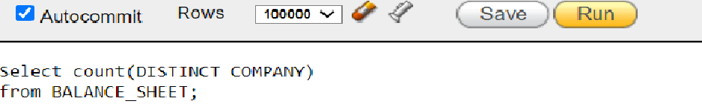

# OUTPUT:

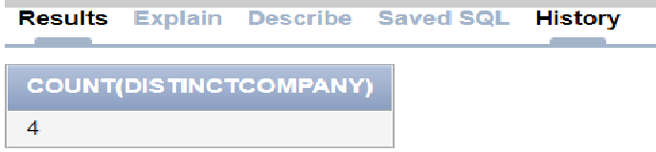

## GROUP BY HAVING COMMAND:

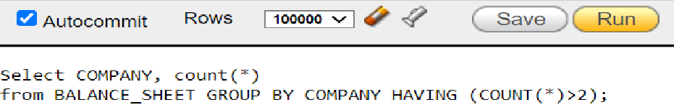

# OUTPUT:

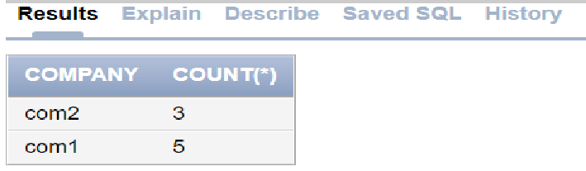

## SUM COMMAND:

## COST ADDITION COMMAND:



# OUTPUT:

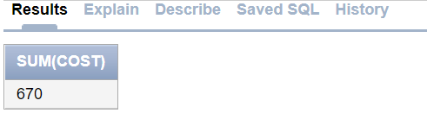

## DISTINCT COST ADDITION COMMAND:



# OUTPUT:

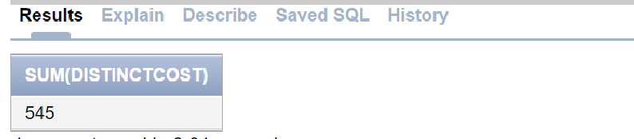

## COST ADDITION WITH WHERE CONDITION COMMAND:



# OUTPUT:

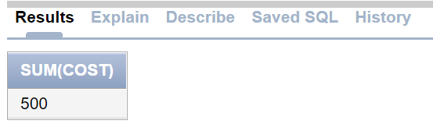

## COST ADDITION WITH GROUP BY HAVING CONDITION COMMAND:

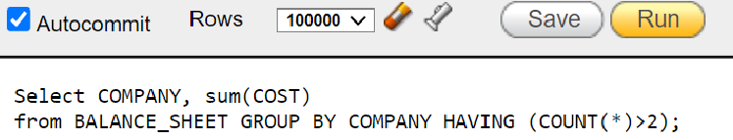

# OUTPUT:

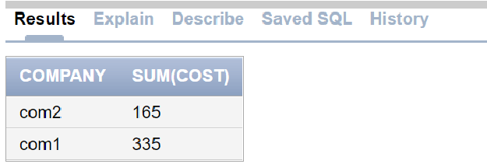

## COST ADDITION WITH WHERE AND GROUP BY COMPANY COMMAND:

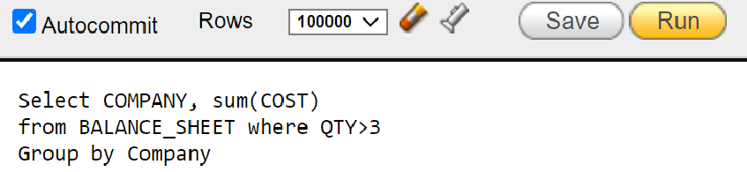

# OUTPUT:

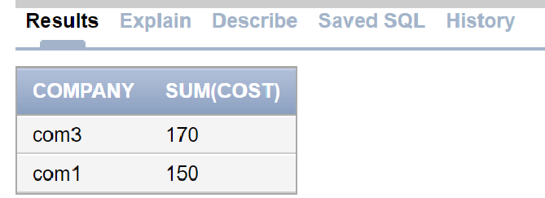

## COST ADDITION GROUP BY COMPANY COMMAND:

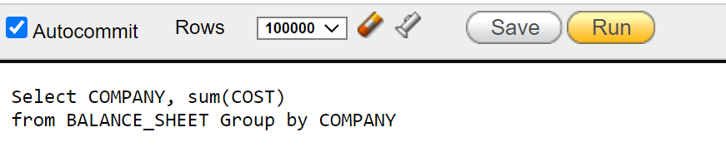

# OUTPUT:

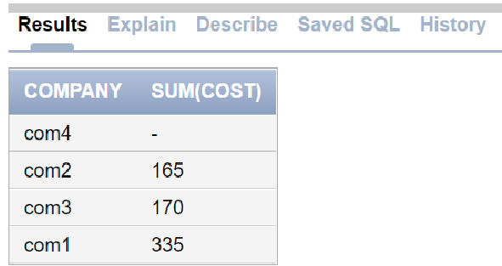

## COST ADDITION GROUP BY COMPANY HAVING COMMAND:

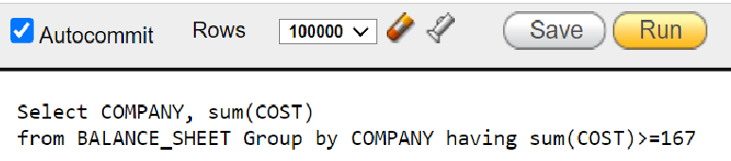

# OUTPUT:

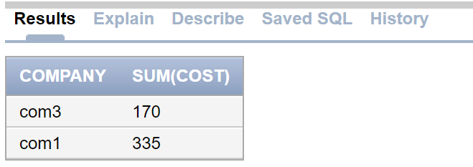

# CREATE BALANCE SHEET TABLE :

## CREATE TABLE COMMAND:

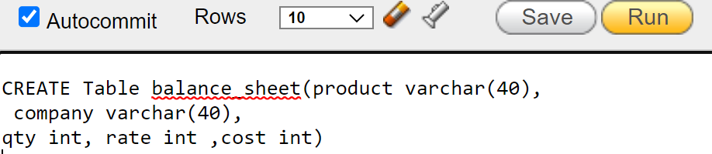

## INSERT MULTIPLE ROWS COMMANDS:

**BABU BANARASI DAS UNIVERSITY**

**LUCKNOW**



**Master Of Computer Application**

**Semester-1**

**School Of Computer Application**

**Relational Database Management System Assignment**

**Session 2022-23**

### Submitted to:

### Mr. Shamim Ahmad Ansari

### Submitted by:

### Syed Waqarul Hasan Naqvi

### Roll No. : 53

### MCA 11